Unit: Striking K-1 Weeks#: 1- 4_ Debra Bruce

STANDARDS OF LEARNING: PHYSICAL EDUCATION
- Demonstrate competence in motor skills and movement patterns needed to perform a variety of physical activities. (Motor Skill Development)
- Apply knowledge of the structures and functions of the body and how they relate to and are affected by human movement to learning and developing motor skills and specialized movement forms. (Anatomical Basis of Movement)
- Achieve and maintain a health-enhancing level of personal fitness. (Fitness Planning)
- Demonstrate the aptitude, attitude, and skills to lead responsible, fulfilling, and respectful lives. (Social Development)
- Explain the importance of energy balance and nutritional needs of the body to maintain optimal health and prevent chronic disease. (Energy Balance)

WEEK 1-4 of UNIT
WEEK1  Focus: | WEEK2  Focus: | WEEK3  Focus: | WEEK 4  Focus:
Learning Target: Striking with body parts | Learning Target: Striking with small implement | Learning Target: Striking with long implement | Learning Target: Striking with long implement
Materials  - Colored Balloons | Materials  - Colored Balloons, Lollypop paddles | Materials  - Plastic Floor hockey sticks, plastic pucks | Materials:  - Putting Golf clubs, golf balls, rolleramas, putting domes, 1st Tee golf balls (Velcro), putting pads
Activity #1:  - Striking the balloon with hands, knees, elbows, head, shoulders.  - Each student will receive a balloon and take it back to a banana spot (personal space).  - Teacher will demonstrate how to strike the balloon in the following order giving time after each demonstration for student to practice:  - Hands  - Elbows  - Head  - Shoulders  - Thighs  - Knees  Music will play after each body part striking is introduced. This will give students time to actively practice the skill. Music will stop playing when it is time to stop after each skill.  Hayden will be placed in an area with a banana spot that will give him enough personal space to move. He will be located half the gym floor distance away from the music. Hayden will try to strike the balloons like the other students during the demonstrations and practice. The assistant/ adapted PE teacher will provide cues following the adapted critical components sheet (provided to them). | Activity #1:  - Striking the balloon with a lollypop paddle in a stationary position using various striking techniques as demonstrated by the teacher.  - The students will choose a balloon and a lollypop paddle and take it back to a banana spot.  - Teacher will introduce to the students how to hold the racquet the proper way.  - Teacher will show the students how to volley the balloon using one side of the paddle, the other side of the paddle, and alternating sides.  - Teacher will introduce to the students how to strike a balloon using a forehand striking motion. There are 5 steps.  - The assistant/adapted PE teacher will guide Hayden through the alternating sides of the paddle by hand over hand assistance until they feel he has grasp the concept.  - During the forehand striking motion, the assistant/adapted PE teacher will prompt Hayden through the 5 steps as learned the previous day. Hayden will follow step 1 like the class. The assistant/adapted PE teacher will help him with step 2 using hand over hand technique. They will touch his left leg for him to step with his left foot. They will toss his balloon up in the air for him. Hayden will then strike the balloon with his hand. | Activity #1:  - Moving the hockey puck around the gym floor by using the following:  Carry, dribble, stick handling  - Students will demonstrate the correct way to carry a hockey stick around with them(blade on floor)  - Students will demonstrate carrying the hockey puck around the gym floor after teacher explains and demonstrates how to do it. (puck stays in contact with blade at all times)  Students will be asked to dribble the hockey puck on the gym floor after teacher explains and demonstrates how to do it. ( soft taps to puck using only one side of the blade) Students will be asked to stick handle a hockey puck after teacher explains and demonstrates how to do it. (Soft taps to puck using both sides of the blade.) Students will stick handle their hockey puck around the gym.  - Hayden will have a hockey stick and a puck. He will place the hockey puck on the floor and place the blade of the stick on the floor beside the puck. Assistant/APE teacher will monitor Hayden and make sure he follows those two direction while he practices carrying the hockey puck with his stick around the gym floor. While the other students practice stick handling and dribbling, Hayden will practice carrying.  - Music will be used to start and stop activity. | Activity #1:  - Putting the golf ball to a target (Rollerama or putting domes)  - Students will rotate station to station putting a golf ball at various targets.  - Teacher will demonstrate the stations to the students.  - Putting-- Teacher will demonstrate the correct way to put to a target using the Y put Y cues. Grip and stance will also be demonstrated as well. These critical components will be performed by the students at every station.  - Students will putt at rolleramas and velcro domes.  - After the students have been divided in to groups by the teacher, the music will start signaling to begin the station. When the music stops, students will stop putting and straighten up the station for the next group. When the music starts again they will rotate to the next station. This will continue until everyone has gone to each station.  - Hayden will rotate through the stations with the assistant/APE teacher. He will have a putter that will be his size to use to putt. They will need to prompt him with visual cues. He may stay at one station if he chooses.
Activity #2:  - Striking a balloon with dominant hand.  - Students will follow the following cues to strike the balloon overhand  - 1.Ready Position Hands by side, feet together, eyes looking forward  - 2. Bring dominant hand back near ear to prepare to hit ball. Hand open.  - 3. Step in opposition with foot.  - 4. Toss balloon in air and strike balloon with dominant hand.  - 5. Follow through and take a bow.  - Hayden will follow step 1 like the class. The assistant/adapted PE teacher will help him with step 2 using hand over hand technique. They will touch his left leg for him to step with his left foot. They will toss his balloon up in the air for him. Hayden will then strike the balloon with his hand.  - Hayden will be assessed for his progress with striking with his hand by the GPE/APE teacher while in class. If he is not successful, Hayden can be re-evaluated at another time during PE in the future. | Activity #2:  - Striking the balloon with the lollypop paddle while moving around the gym floor. (On the move.)  - When the music starts, the students will partner up and practice volleying the balloon back and forth to each other using the overhand strike. When the music stops, the lollypop paddles and balloons will be returned to the teacher.  - Hayden will pick a partner first. Should he not want to choose a partner, can continue to hit the balloon using the forearm motion. If this proves to be too challenging, Hayden may hit the balloon by his choice of striking.  - He will need to be monitored for special awareness and time on task. | Activity #2:  - Pass the puck to a partner using a push pass.  - Students will be paired up for the push pass. Teacher will demonstrate how to push pass a puck to a partner. Puck will remain in contact with the hockey stick while it is being passed.  - Hayden will be paired with a student by the teacher. He will push pass with the help of the assistant/APE teacher using the hand over hand method to guide him. He can try it by himself if assistant/APE teacher feels he is ready. Safety is a must and he must be watched continually. | Activity #2:  - Challenge a partner to see who can score the lowest score in putting.  - Students will add up scores at the target stations. Each target has numbers 1, 3, 5 on them. Student with the lowest number did the best at that station.  - Hayden will add his target numbers up also. If he is at a station with his fellow classmates, he will participate by announcing his scores to his classmates. Assistant/APE teacher will help him add his numbers together.
Activity #3  - Striking a balloon with a partner trying not to let the ball touch the ground. Students can use any body parts that we went over in class.  - Students will pick a partner to hit the balloon back and forth during the last 5 minutes of class. They may use any body part that was introduced in class.  - How many times can you pass the balloon to your partner and not let the balloon touch the ground?  - Hayden will pick a partner first. Assistant/adapted PE teacher will monitor him and make any necessary adjustments that he may need to be successful. | Activity #3  - Striking a balloon while moving around the gym floor.  - When the music starts, students will practice striking the balloon while moving around the gym floor being aware of other students around them till the music stops.  - Hayden will practice striking the balloon like the other students in his class. He needs to be aware of his surroundings. Assistant/APE teacher will follow him to make sure he is being safe. | Activity #3  - Choice of carry, dribble, or stick handle to music for 2 minutes independently. They may do all three if they want.  - When the music starts, students will begin carrying, dribbling, or stick handling around the gym floor.  - Students must be aware of other students around them and not raise their hockey sticks above their knees. No slap shots today.  - Hayden will move around the gym demonstrating carrying the hockey puck. Assistant/APE teacher will prompt and remind him of protocol for carry and safety. | Activity #3
SAFETY | SAFETY | SAFETY | SAFETY

Skill #1: Striking a balloon with your hand/body parts_

Critical Components | Adapted Critical Components
Eyes on balloon | Let Hayden pick his favorite color balloon so he will look at it. ***
Strike balloon with hand, shoulder, elbow, thigh/knee, foot, or head | Hayden will choose his favorite body part to strike the balloon to keep it going for 30 seconds. ***
Don’t let balloon touch the floor | Try not to let the balloon hit the floor to the best of his ability. ***
Continuous striking | Hayden will strike the balloon at least three or more times in a row. ***
Spatial awareness- Banana spot on floor | Hayden will find a banana spot of the floor farther away from the music. He will close to his banana spot during the lesson. ***
 | ***Hayden’s assistant or adapted PE teacher will be with Hayden during the lesson to assist him with staying on task. ***
 | Hayden will be placed in an area of the gym to give him extra room to move and be successful.

Skill #2: Striking the balloon with a lollypop paddle (short implement)

Critical Components | Adapted Critical Components
Ready Position(Hands, Feet, Eyes) | Hayden will stand in ready position –paddle in dominant hand (right), feet together, eyes ready for action. Hayden will use a regular lollypop paddle and choice of color of balloon. ***
Dominant Hand back (near ear) | The assistant/adapted PE teacher will assist Hayden hand over hand to help him bring the paddle back near his ear. ***
Step in opposition (with foot) | The assistant/adapted PE teacher will touch Hayden’s left leg to signal him to step with his left foot. ***
Toss Balloon with non-dominant hand and Strike Balloon with Dominant hand. | The assistant/adapted PE teacher will help Hayden strike the balloon using a hand over hand approach. Either will toss the balloon for Hayden to hit with the paddle. If Hayden would like to try to toss and hit the balloon, he will be allowed to try with their assistance. ***
Follow through (Take a Bow) | Hayden will take a bow. (prompted)***
***Hayden will have the assistant/adapted PE teacher to assist him with the cues and physically help him with the skill. ***
Hayden will be placed in an area of the gym to give him extra room to move and be successful.

Skill #3: Striking with a long implement (plastic hockey stick)

Critical Components | Adapted Critical Components
Ready Position-- Dominant hand on shaft, Non-Dominant hand on Handle of the plastic hockey stick. | With assistance, Hayden will place dominant hand on shaft and non-dominant hand on handle of hockey stick. Hayden’s hockey stick will be a small size stick appropriate for a first grader of his height. ***
Blade on Floor | With assistance/prompt, Hayden will place blade on floor. Hand over hand may be used to remind him to keep the blade on the floor. ***
Puck against blade | Hayden will place the puck next to the hockey stick blade. The assistant/adapted PE teacher will remind him to keep blade on floor and puck next to blade. ***
Carry, Dribble, or Stick Handle (on command) keeping hockey below knees | Hayden will carry the hockey puck with the hockey stick. Hand over hand help. He may try on his own if the assistant/adapted teacher feels he can handle it or if he expresses an interest. ***
Keep control of puck | Hayden will need to be monitored closely for safety reason by the assistant/adapted PE teacher. He will need to keep the puck touching his hockey stick. He is not allowed to raise it above his knees. ***
 | ***Hayden will have the assistant/adapted PE teacher to assist him with the cues and physically help him with the skill. ***
 | Hayden will be placed in an area of the gym to give him extra room to move and be successful.

Assessment for one of the three skills:

PROGRESSION REPORT

Rubric: Striking with hands Name:_Hayden____________________
Component | Trial 1 | Trial 2 | Trial 3
- Look at your target. Use your eyes.

The Balloon

- Strike the balloon with your hand

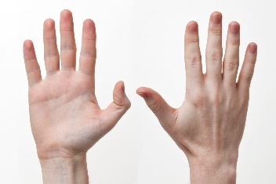

__Right hand __Left Hand

- Hit the balloon consistently 3 times.

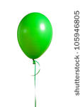

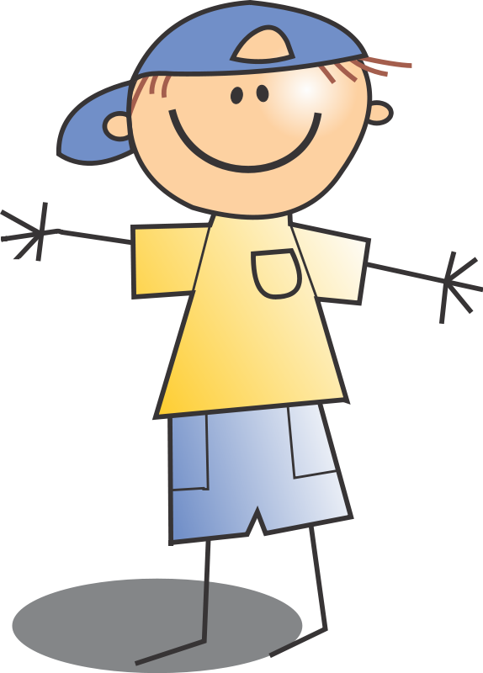

- Don’t let it touch the floor.

Balloon in air.

Banana spot on floor.

5.Stay in your own personal space

Banana Spot

****Hayden was successful with this skill if two (2) of the trails in each category is √. The assessment will be completed by the APE or regular PE teacher. ****
Hayden also has an on task dinosaur puzzle. The outline of a dinosaur (laminated) has colored pieces (laminated) that are placed on the dinosaur if he is on task during class. Once the puzzle is completed, he knows he did a great job with his skills, attitude, and behavior. If the puzzle is completed by the end of class, Hayden is given an 8x10 picture of a dinosaur to take back to the class with him to color. The pieces are then placed back in a zip lock baggie and placed back in my office for the next time he comes to PE class.

How will you know if your student met the learning target? This assessment can be a checklist, self-assessment, peer-assessment, etc.
See Attachment above

